

VERTICAL DIFFUSION PM PROCEDURE (TEOS)
PM Type: SPM- Small PM Prepared By: Michael,卡莫那
Machine: LP-POLY Department: S200 Furnace
PM: Frequency: Date: November 2019

Step 1. Check in the computer if the machine is scheduled to PM. | Step 2. Check Machine status.
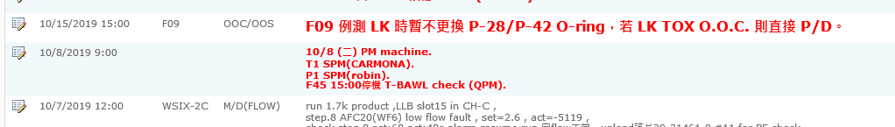 | 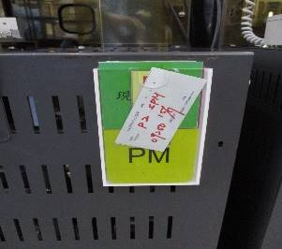  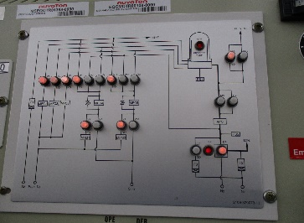  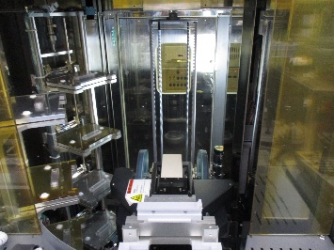  Machine Label.  ATM Mode: Red Light ON  No Cassette and dummy wafer to the boat.  1  2  3

Step 3. Get VL800 and go to the back of the machine. | Step 4. Put sign that you have a work to do before you continue to work.
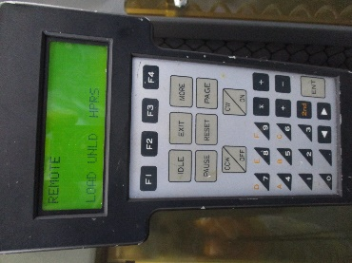 | 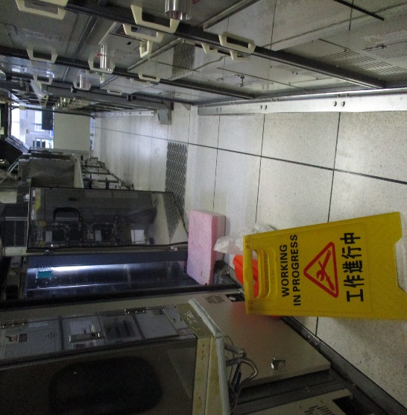

.

Step 5. Remove boat. Unlock boat lock using VL800. Go to M05 and press CW/ON . If release unload the boat. | Step 6. Unload the boat carefully by 45 degrees and avoid contact to other parts of the machine.
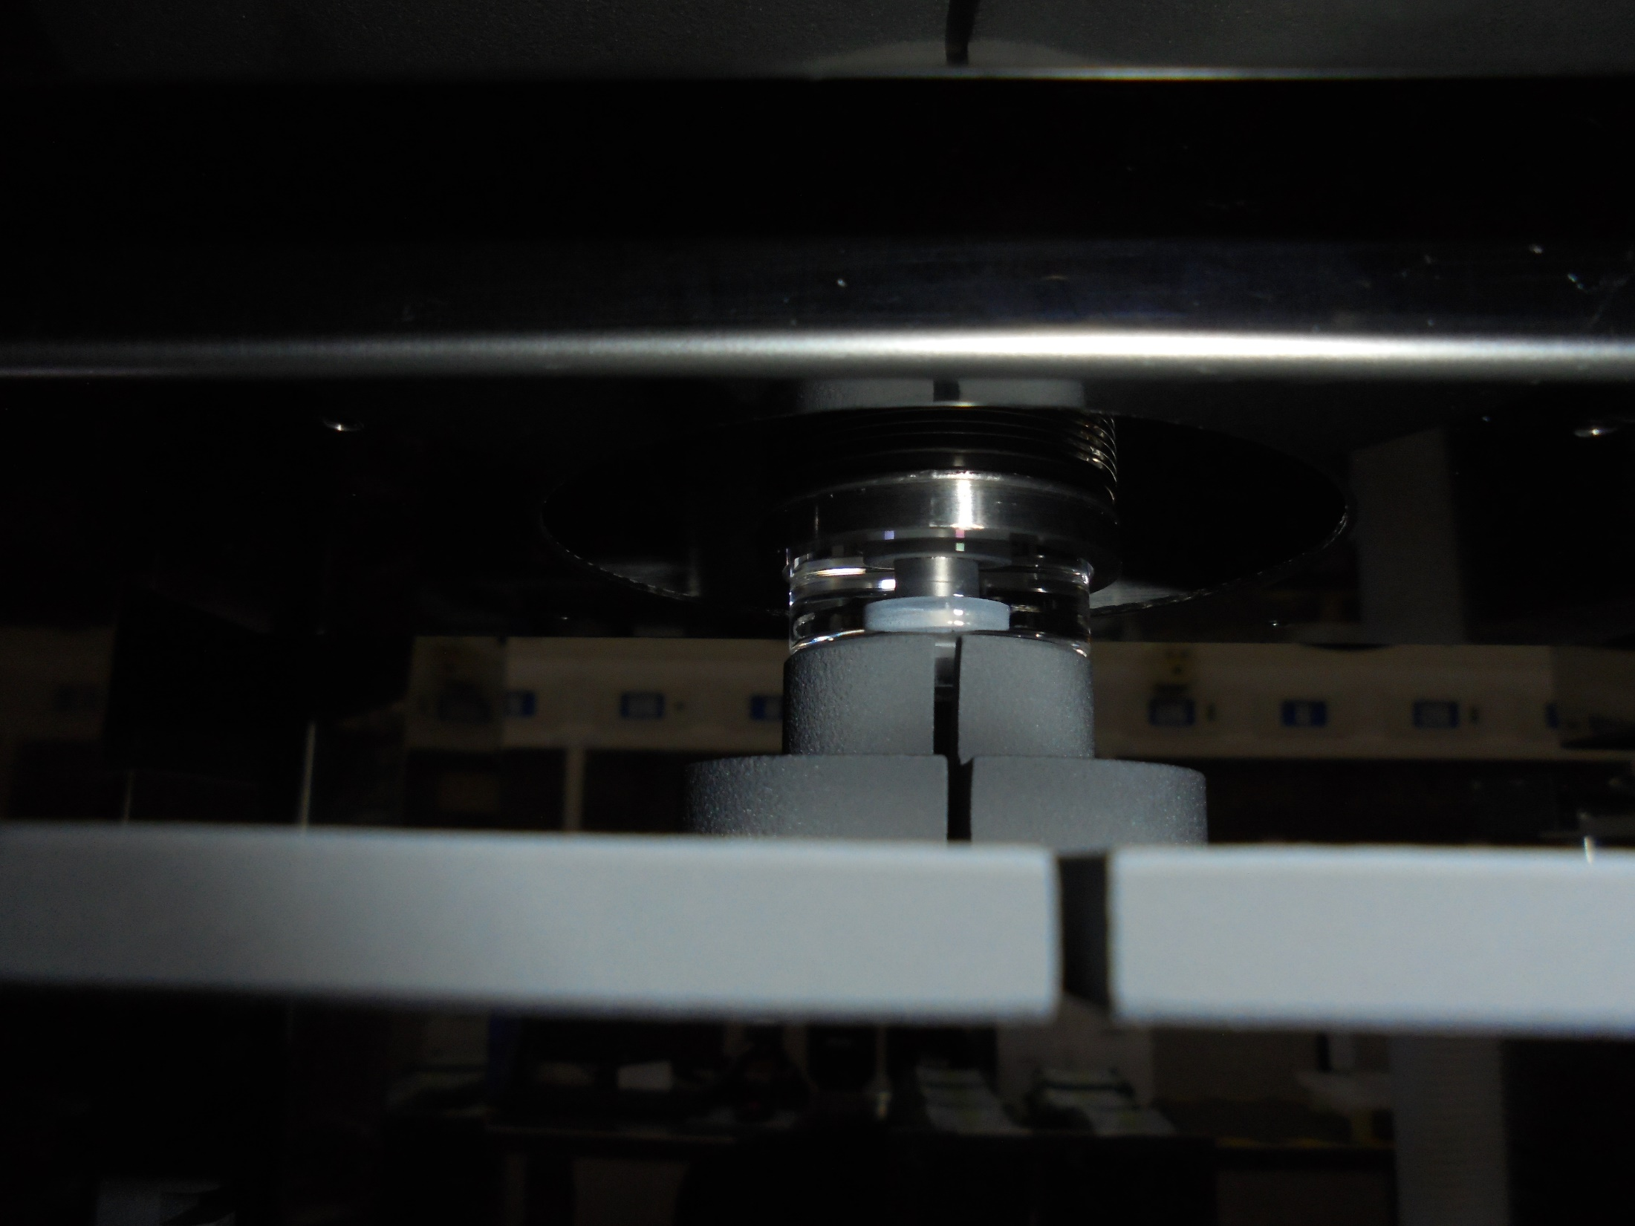 | 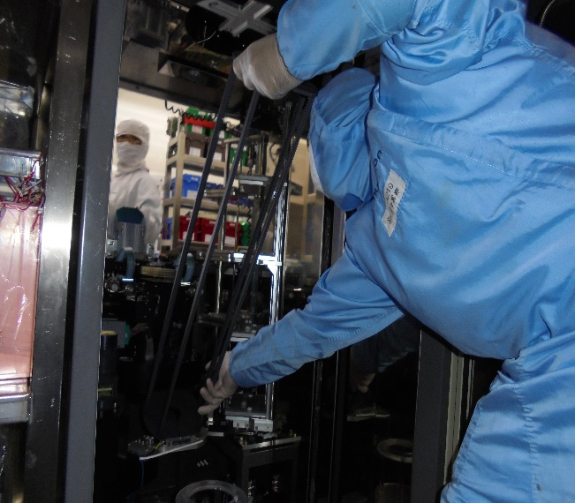

Step 7. Change the boat. To load the boat, angle the boat to 45 degrees and put it in the robot arm. | Step 8. Check the gap of the boat and arm sensor to avoid any damage.
 | 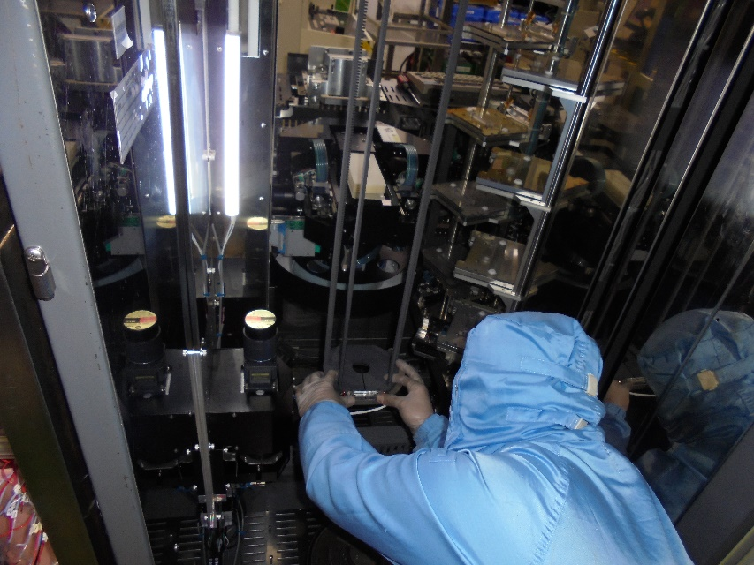

Step 9. Check alignment of boat and pedestal make sure the gap is balance from pedestal to boat. | Step 10. Adjust 3 points of the boat arm to avoid vibration and shaking and to avoid NG of the products.
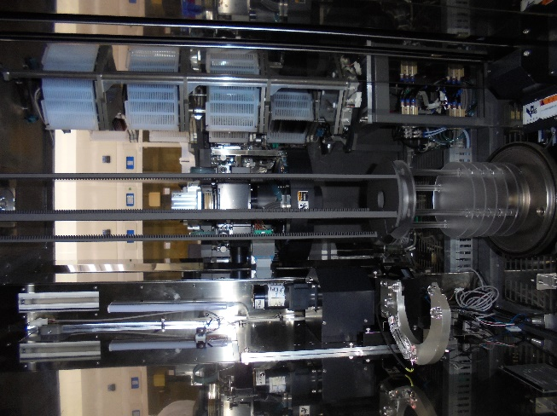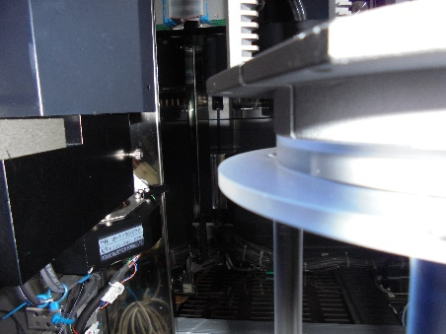 | 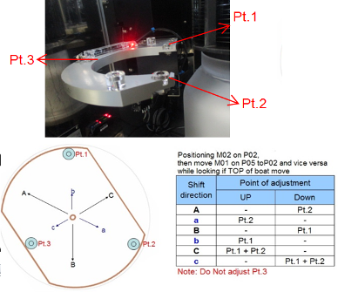

Step 11. Position the boat to P01 to check and adjust the load luck.  Note: The boat luck and the boat should be level. | Step 12. Load C1 To C8 cassette dummy to check transfer.
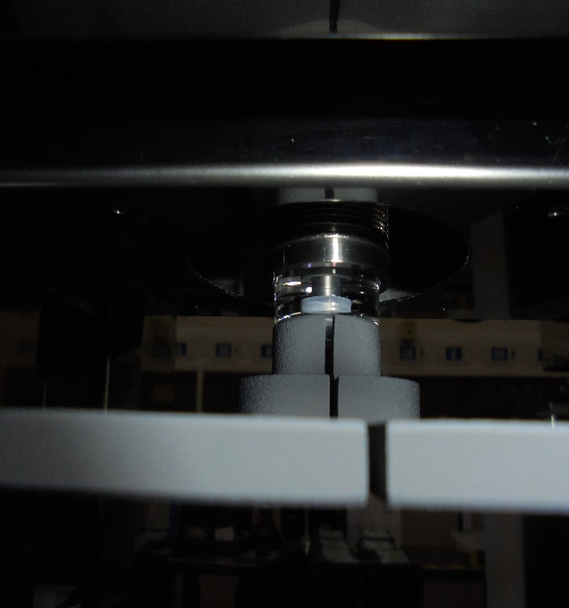

Step 13.0 Transfer check from Fork 5 to Fork 1.
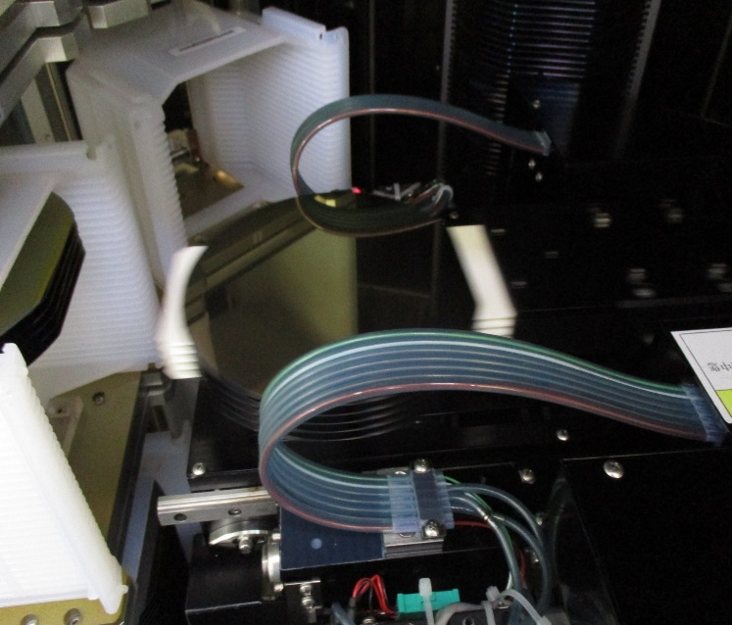
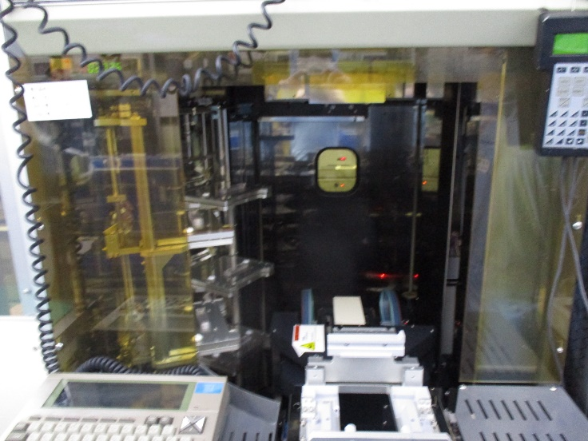
Wafer Must be center.
Good
Fork 5 values.
C1 016 ,156
C2 046
C3 071
C4 096
C5 121
C6 146
Fork 1 values.
C8 21 B015, B155
C1 B014, B154
C2 045
C3 070
C4 095
C5 120
C6 145
Make sure the wafer in every fork is on the center of the fork, do not allow the wafer to over lap to the fork.
Note: To check the gap of the wafer you have to open the back light and use mirror or go to the back of the machine to make it 100 % sure if not use flash light.
Make sure the wafer in every fork is on the center of the fork, do not allow the wafer to overlap to the fork.

Step 13. 1 Transfer check from Fork 5 to Fork 1.
Remove the front cover of the machine.
Check gap of fork 5 and fork 1 in the cassette from front to back by using mirror. The fork should be in the middle and not to touch the wafer.
NG
Good
Fork should be in the middle to avoid damage and scratch and damage to the wafer.

Step 14. Unload all the wafer back to the cassette.  Note: Watch it very carefully and your finger is ready to pause the process or abort for process abnormality. | Step 15. Unload all cassette from C1 to C8 and ready to pause for abnormality or air leak. If so call EQ.
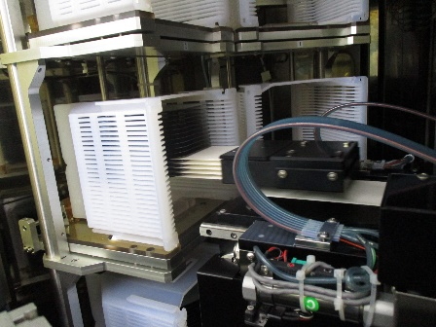
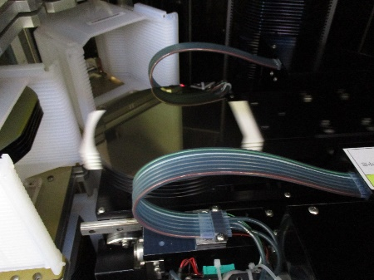

Step 16. Boat UP. Use VL800 at the back of the machine for safety. | Step 17. Run manual purge for 1 hours.
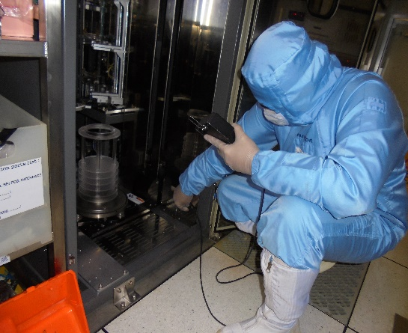  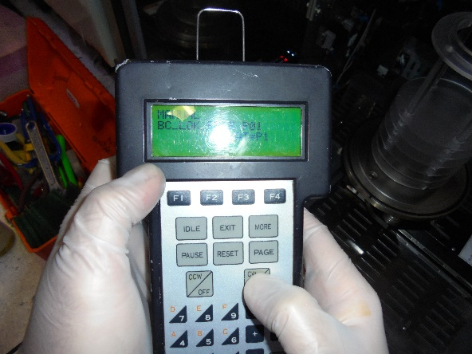 | 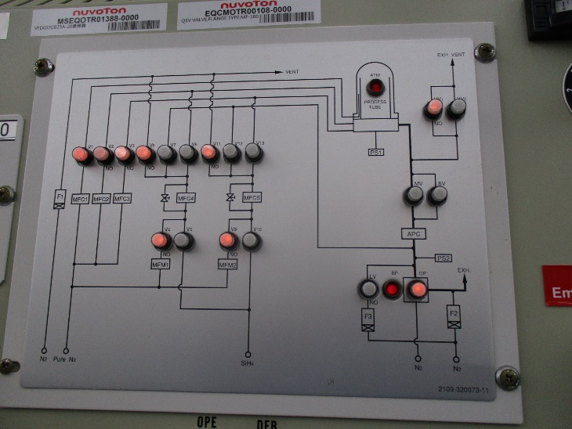  To run manual purge open SV and if the pressure is below 5.0 Toor Open MV wait till 00.00 Toor set MF1, Mf2, Mf3 to get pressure of around 1 Toor  Open Pressure and Pure N2 gas supply.

Step 18. After 1hr of manual purge run auto coating.

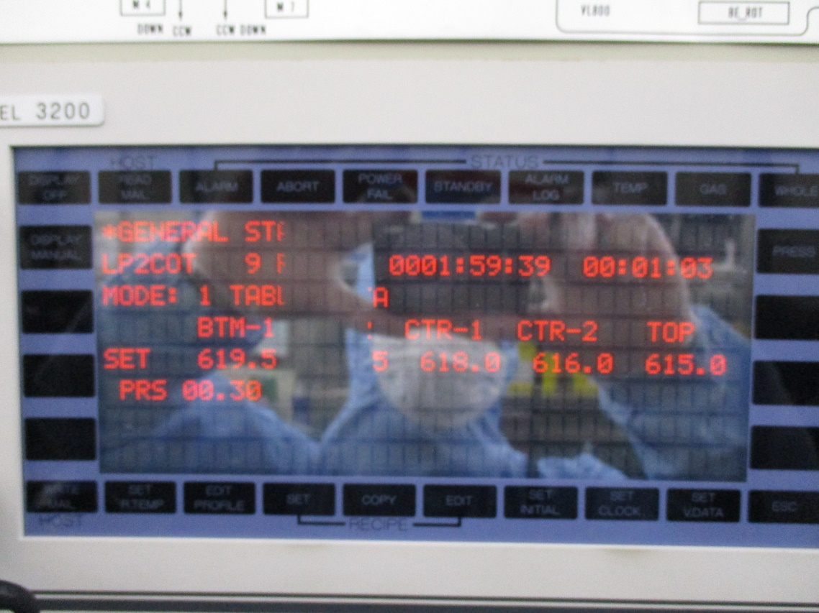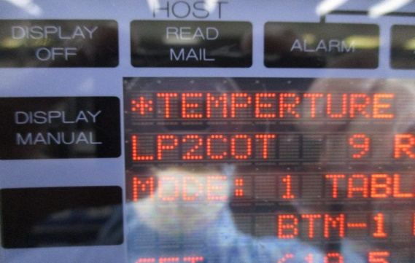
Set
ESC
Whole
Temp
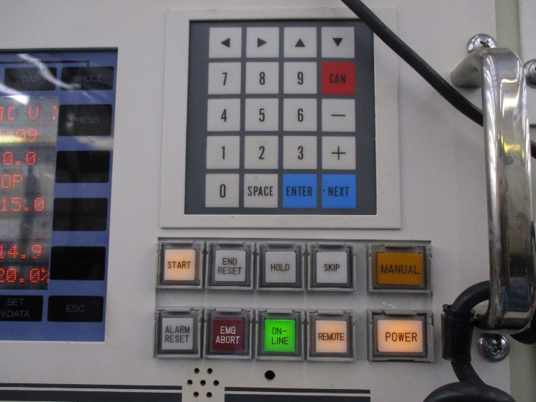
Step to run auto coating.
Click set
Input password “ Space + 2 “.
Click ESC
Click Whole And confirm the recipe of coating.
Click Temp. to check the temperature and double check the coating recipe.
Click start if not check button if the remote is off.
Check VL800 if M01 to M06 is in P01 or if all is in P01 Then click Start button.

Step 19. If the boat is up already and the process of coating is starting clean machine.
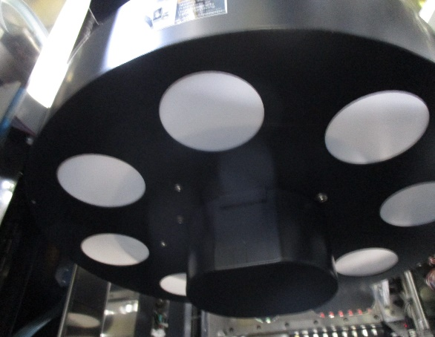
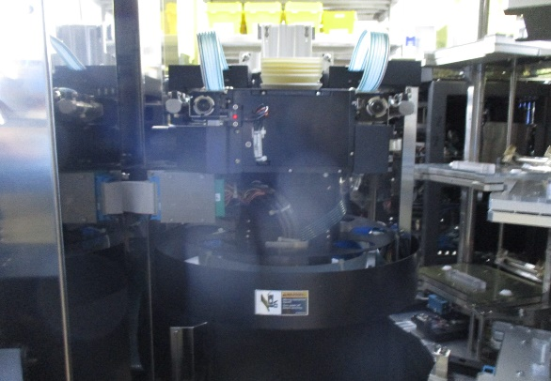

Clean robot assembly.

Remove 3 screw and clean the cover.
Use vacuum, wiper and IPA.

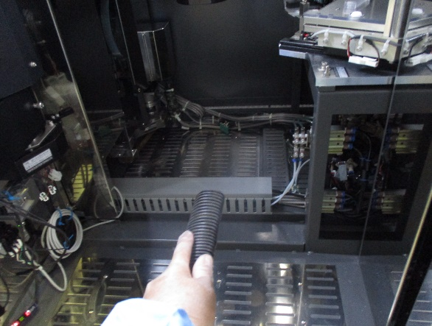

After cleaning robot assemble use low vacuum to clean chamber and wipe it with IPA to make sure no particle..

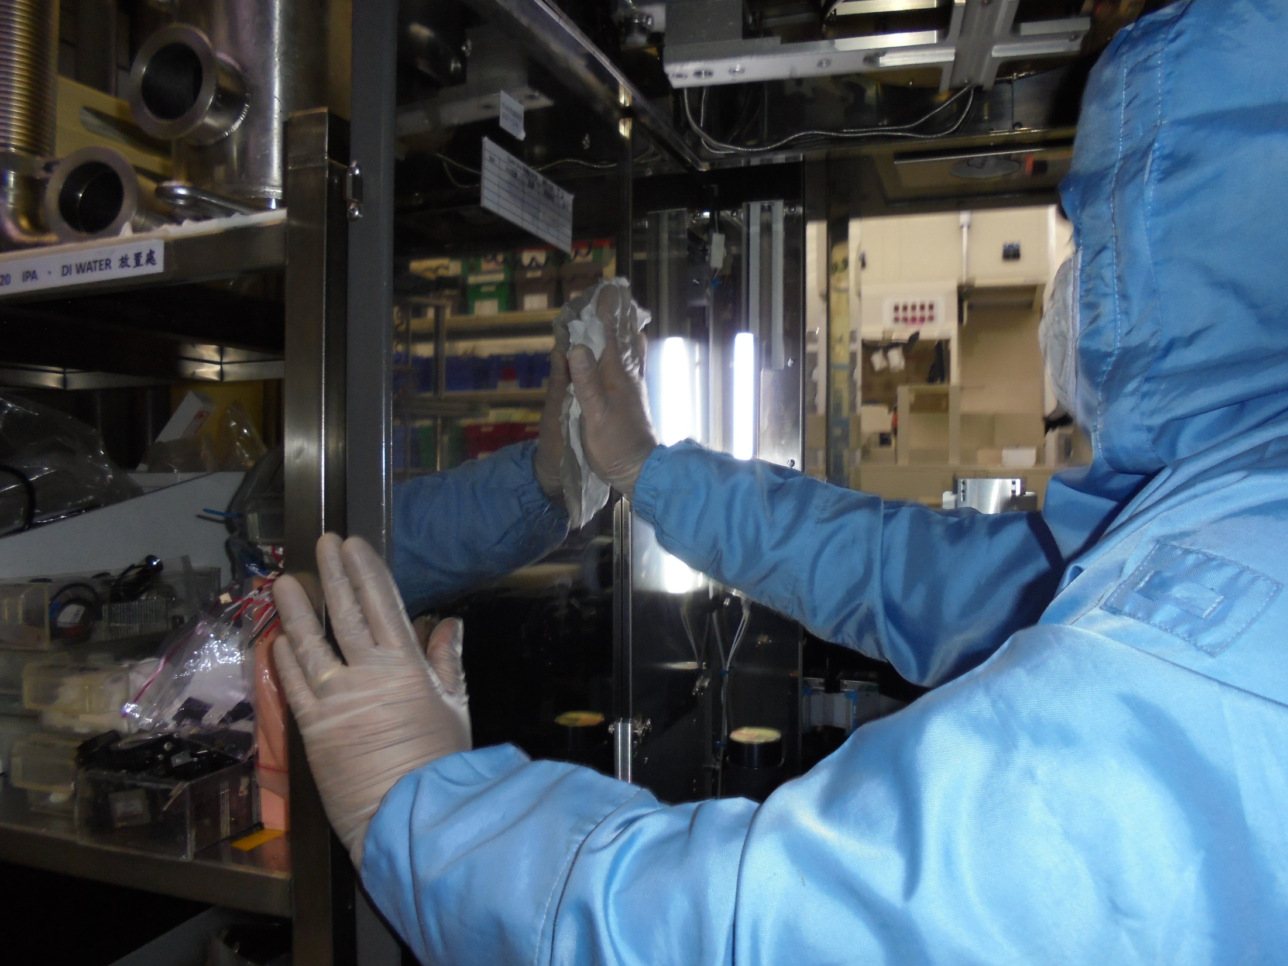
Clean chamber wall use wipes and IPA.

